TABLE OF CONTENTS

Content Page

Introduction

Establishing a Broiler Unit
- Location
- Transport
- Water
- Size and cost of land
- Electric power
- Proximity to market
- Personal qualities

Housing

Feeding

Management
- Selection of quality chicks
- Placement of chicks
- Brooding management
- Watering
- Feeding

Health and Disease
- Vaccination
- Culling
- Diseases

Conclusion

SMALL SCALE BROILER PRODUCTION IN GUYANA

INTRODUCTION

The rapid growth of the local broiler industry over the last decade, has been as a result of expansion of primarily medium to large scale operations. Despite this, the significance of the backyard or small scale producer cannot be overlooked.
The growth potential of the modern day broiler is phenomenal in that the newly hatched chick weighing an average of 38 grams can attain a weight of 2kg in 35 days if given the correct nutrition and management.
Following are some general recommendations, aimed primarily at the many small scale broiler producers who contribute to broiler production in Guyana, but whose management is often found lacking.

ESTABLISHING A BROILER UNIT
There are a number of points to consider when a broiler unit is to be established. These points are described below:
Location
One of the first points to consider is the location of the farm. Is the site far removed from transport facilities? Does it lack water and could a shallow well be put down? Is the land subject to flooding? Or is it liable to bush fire hazard?

Transport
For every 5 000 broiler – approximately 55 tonnes of feed, 30 tonnes of birds and 25-30 tonnes of manure have to be transported.

Water
An adequate water supply of reasonably good quality is essential. One thousand birds can drink up to 90 gallons a day, depending on temperature conditions.

Size and cost of land
Secure low or reasonably priced land, offering room for expansion and the building of additional facilities in the future.

Electric power
A farm can be worked successfully without power, but electric power is a great help for many reasons. It makes life somewhat easier for workers.

Proximity to market
The greater the distance from the market, the higher are the transport costs.

Personal qualities of the poultry farmer
The capacity for meeting routine obligations, as well as a general aptitude and liking for poultry are important requirements.
A liking for poultry farming does not mean that a man must love the birds – he must have a liking for the type of life although a liking for the birds will be a distinct advantage.

HOUSING

It is preferable to fill your house with chicks from one source and have the same age group of birds in each pen. Multi-aged flocks perpetuate diseases; at times in sub-clinical forms; and new arrivals rearly attain the weight gains expected of them, so an all in all system is best.
Width of the house should not exceed 9.2 meters (30 feet), this is in order to promote proper natural ventilation (Figures 1 & 2). There are more chances of spreading disease if houses are constructed within 50 feet (15.4 m) of each other.

Under intensive rearing, most of birds are kept under a deep litter system. In terms of financial outlay, housing usually works out to be about 10-15 per cent of the total cost of production. The floor space recommended is 1 sq.ft. per bird on the coast and 1.3 – 1.5 on the highway and white sands.

* Air movement should be 30 ft (9.2 m) per minute this should allow for one complete air change per minute.

Ventilation
Proper ventilation is one of the crucial aspects of broiler production. The fast growth rate of birds, high stocking rate (1sq. ft/bird) and the need to grow birds to heavier weights have made ventilation even more important today. Ventilation

a) removes excess heat and moisture;
- provides oxygen while removing harmful gases e.g. ammonia;
- reduces the build up of dust and improves air quality;
- facilitates high stocking rates in a pen; and
- reduces upper respiratory tract disorders.

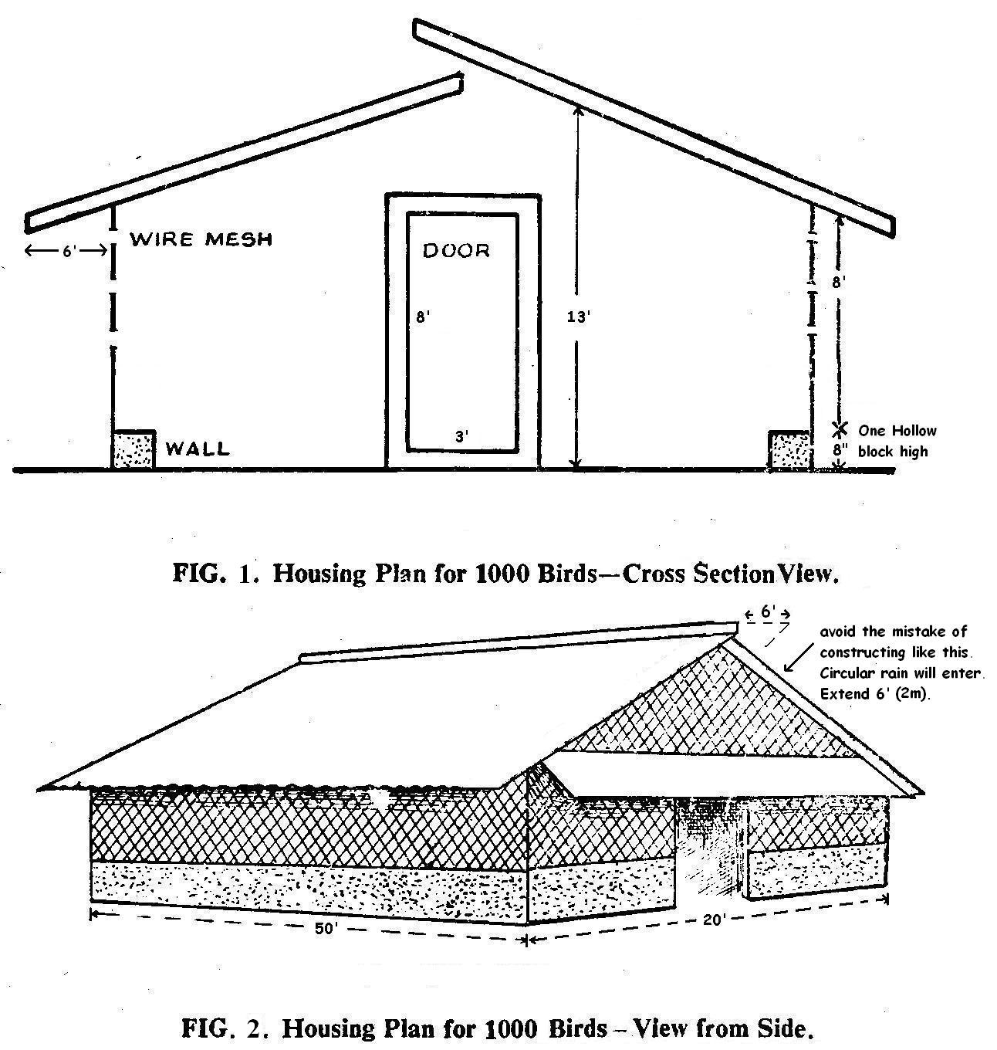

FEEDING

Two primary objectives of feeding broilers are to have fast growth and an economical feed conversion.

Several types of broiler feeding programmes are popular throughout the poultry industry with the following, being the most widely used.

Feeding pellets or crumbs improves feed efficiency compared to the feeding of mash.

Program 1
Wks. 1-3 broiler starter
Wks. 4-5 broiler grower
Wks. 6-finish broiler finisher

Program 2
Wks. 1-5 broiler starter
Wks. 6-finish broiler finisher
Expected growth rates should be demanded on receipt of the chicks.

To avoid feed wastage maintain the height of all feeders so that the lip of the feeder is level with the back of the bird. An example of a chicken feeder is shown in Figure 3. In trials, different levels of wastage by the birds were observed when feeders were filled to various levels:
- When feeders are filled, 30% of feed is wasted
- When feeders are ⅔ full, 10% of feed is wasted
- When feeders are ½ full, 3 % of feed is wasted
- When feeders are ⅓ full, 1% of feed is wasted

Feed wastage from overfulling feeders may be better understood by keeping a neat newspaper under each feeder and noting the wastage of feed. Feed wastage influences farm income, since 60-70% of the expenditure goes towards the feed cost. The use of a hanging feeder (Figure 3) with a 6 cm diameter is also recommended. Thirty three such feeders are recommended for every one thousand (1000) birds.

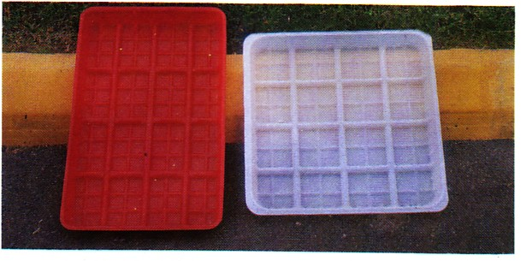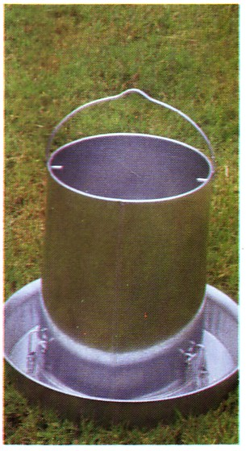
FIG. 3. Chick Feeder Tray FIG. 4. Hanging Feeder
MANAGEMENT

Proper management is critical for a successful broiler enterprise. The following are key ingredients for a successful management programme.

1. House and equipment preparation
Cobweb and wash the entire house from top to bottom and then apply a suitable disinfectant. In the process, remove, clean and sanitize all feed containers, waterers and other equipment.
Prior to the arrival of the baby chicks, lay down the litter, bag or curtain the sidewalls, and on the day of arrival, provide clean, fresh water and feed.

2. Selection of quality chicks
A broiler can be defined as a young meat type chicken, normally raised for a period of 6-8 weeks. The selection and purchase of quality chicks is important to a profitable operation. Chicks should be uniform, alert and active, free of deformities, with no sign of navel infection and “Black Bottom” disease (omphalitis). Additionally, they must not have crossed beaks or crooked legs. Quality chicks should be bright eyed, dry and fluffy and not be dehydrated, as evidence by a dull, dry, withered looking leg covering with indentation between the toe joints.

3. Placement of chicks
All equipment (feeders, waterers, heaters) should be set up and carefully tested atleast 24 hours before the arrival of the baby chicks. Activate heat sources before hand so that chicks enter in a sufficiently warm house. Even short periods of chilling can significantly reduce the growth potential of the chicks.
Carefully remove chicks from crates and place from back to front within the brooding area; this is important to avoid stepping on chicks. Allow chicks to drink for 2-3 hours before introducing feed. The first drink the chicks get, should contain electrolytes. It is also suggested by NARI, that antibiotics are given for the first 3-5 days in instances where post mortems suggest certain types of infections. A vet or vet assistant should be involved in any such decision to use antibiotics this early.
Visit the house several times during the first day to ensure that the chicks are eating and drinking normally and that all is well. Comfortable chicks are quiet and uncomplaining.

4. Brooding management
Brooding is an essential practice in rearing. It refers to the care management of the chicks, during the first few days of life and is the basis for achieving consistently good performance. A small area, within the house, that can comfortably accommodate the baby chicks (about ⅓ the floor space) should be enclosed, to concentrate heat in the brooding area (ensure the corners are rounded). Where heat bulbs are used for brooding, 400 watts is usually effective in satisfying the heat requirement of 1000 birds. Other heat sources include: heat lamps, coal fires, oil burning Chinese stoves and saw dust burning (Figure 5). These sources have risks and limitations.
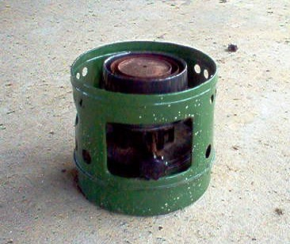 | 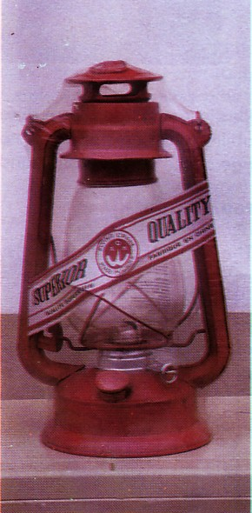 | 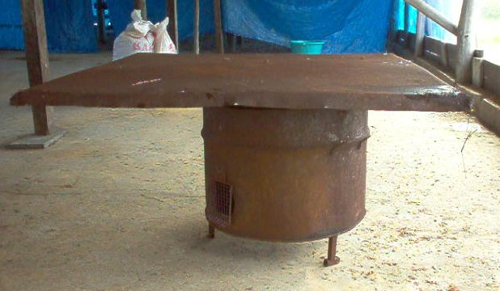
Chinese Oil Burning Stove | Storm Lantern | Saw Dust Brooder (burner)

Fig. 5: Other heat sources for broilers

Whatever the brooding system used, the desirable temperature should be maintained at 35˚C (95˚F) at the level of the birds, throughout the first week, regardless of outdoor temperature. Comfort can be verified as follows:

- Correct Too cold - chicks will peep and pile up under the brooder.
- Drafty - chicks will avoid certain areas of the pen.
- Too hot - chicks move away from heat source.
- Correct temperature - chicks are quiet and evenly distributed around the brooding
area .

Watering
On arrival, chicks should have access to sufficient, fresh, clean water, kept at room temperature and fortified with electrolytes. Chick founts (Figure 6) or circular automatic waterers (Figure 7) should be located close to the brooder, about 45cm (18”) away and placed alternate to the feeders. Availability of drinking space is more important than the amount of water in the waterer, hence, several small waterers are better than a few large ones, when starting chicks.

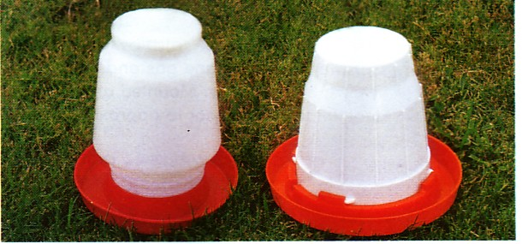
Fig. 6 . Chick Founts
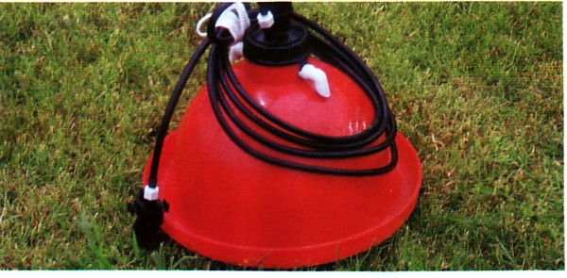
Fig. 7. Circular Automatic Drinker

Recommended – 1cm per bird drinking space
NARI recommends – 15 circular automatic drinkers per 1000 birds

HEALTH AND DISEASES

Poultry diseases at times cause serious losses to the poultry owners and many diseases can be traced to faulty management. Factors such as chilling, overcrowding, power outages, rat infestation, wet and contaminated litter and mouldy feed predispose birds to many diseases. The axiom “prevention is better than cure” applies more to poultry production than to most types of livestock production, because of the high population density in poultry houses. From an economic stand point it cannot be overemphasized that preventative management is often much better than treatment of disease. Stress also plays a role in the health of birds. Factors such as improper application of feed, lack of water, the act of vaccinating, the onset of disease, fright, conditions of draught and excessive heat are significant causes of stress.

Vaccination
Vaccination often provides the chickens with the immunity necessary for protection against some diseases, particularly viruses. Many are done at the hatchery, which enables the immune system to start building the immunity necessary, before exposure on the farm to the field viruses and pathogens.

Culling
Culling is the practice of removing birds from the flock that are poor growing, crippled, injured, deformed or generally unhealthy and undesirable. Culling is worthwhile in:

- the prevention of disease;
- increasing floor, feed and water space for the remaining birds;
- reducing feed and production costs;
- improving feed efficiency.

Dead birds should promptly be removed from the house and buried, burnt or properly disposed to prevent any spread of disease.

Common diseases of poultry.
1. Viral diseases: (a) Fowlpox
(b) Marek’s disease
(c) infectious bronchitis
(d) infectious bursitis (Gumboro)
(e) Newcastle disease

2. Bacterial diseases: (a) infectious coryza
(b) salmonellosis
(c) CRD

3. Fungal diseases: (a) aspergillosis (brooder pneumonia)
(b) aflatoxicosis

4. Parasitic diseases: (a) coccidiosis
(b) helminthiasis

VIRAL DISEASES

Disease | Symptoms | Post-mortem findings |  | Prevention | Treatment
Fowlpox | Wart-like scales and lesions on comb, wattles and unfeathered portion of head (Figure 8) | Inflammatory changes in the respiratory tract, mouth, eyes and nostrils |  | Vaccination | Administer fowlpox or pigeonpox vaccine to unaffected bird
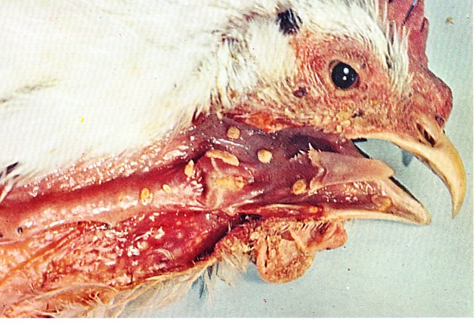 |  |  | 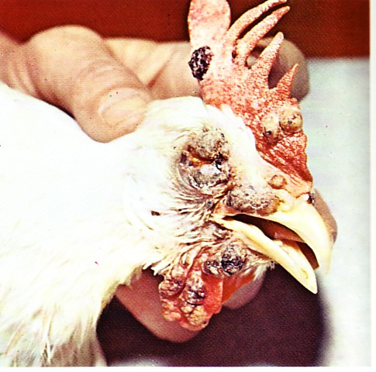
Fowl pox (“wet” form)  Cankers are imbedded in the membranes of the mouth, throat and windpipe. Cankers may grow together and form a false membrane. When cankers close the opening of the windpipe, death results from suffocation. |  |  | Fowl pox (“dry” form)  Brown scabs start as small, rapidly growing white bumps. Lesions most often appear on comb, face and wattles.
Fig. 8: Symptoms of Fowlpox.

Marek’s disease | Viral-paralysis of both legs, wings and neck  Acute forms – sudden death. (Figure 9) |  | Liver, gonads and spleen are enlarged with nodules swollen nerve tissue and enlargement of feather follicles (bumpy skin). |  | Vaccination |  | None
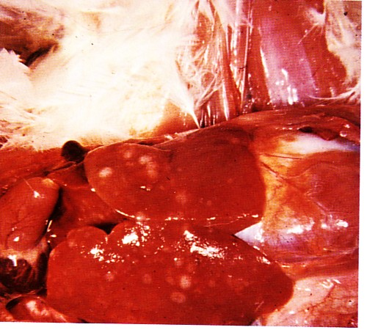 |  | 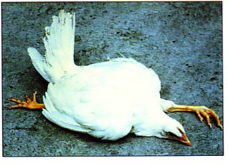 |  | 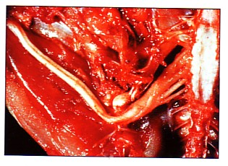 |  | 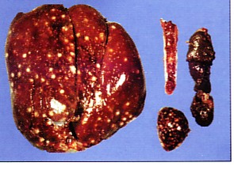
Tumors on the liver and other visceral organs are often noted. Leg and wing nerves may be swollen |  | Leg paralysis |  | Enlarged sciatic nerve.  The paralysis is caused by lesions and enlargements of the affected nerves. |  | Tumors may be observed in the ovaries.  In acute form visceral tumours are most common.
Fig. 9: Symptoms of Marek’s disease

Disease | Symptoms |  | Post-mortem findings |  | Prevention | Treatment
Newcastle disease | Laboured breathing with weezing, gurgling, gasping, coughing, hoarse chirping, rattling of the wind pipe.  Nervous signs – moon gazing, inco-ordination  (Figure 10) |  | Froth in the trachea and on airsacs, haemorrhagic lesions in proventriculus. |  | Vaccination | None
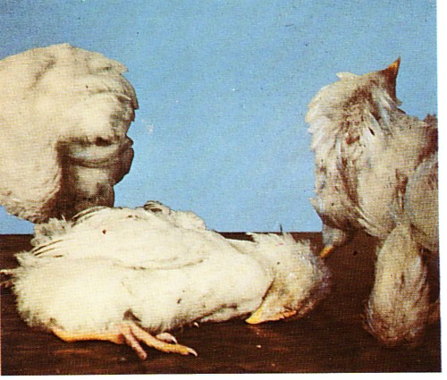 |  | 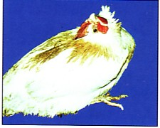 |  | 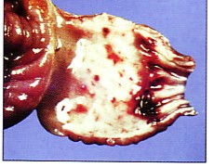
The common signs when nerves are affected.  Bird may have complete or partial paralysis pf legs and wings. |  | Neurotropic form of Newcastle Disease |  | Haemorrhagic proventriculus
Fig. 10: Symptom of Newcastle disease.
Infectious Bursal Disease (IBD), Gumboro | 2-6 weeks  Droopiness, severe prostration incoordination, wobbly gait, whitish diarrhoea, soiled vent feathers.  (Figure 11) | Dehydrated, haemorrhage in legs and pectoral muscles, enlarged liver, spleen, kidney and bursa of fabricus atrophied or enlarged |  | Vaccination | None
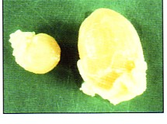 |  |  | 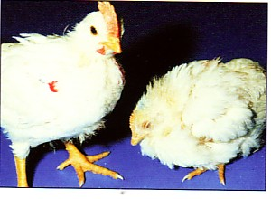
Normal (right) and affected bursa three days post infection |  |  | Infectious bursal disease infected chicken (right)
Fig. 11: Symptoms of Bursal Disease (IBD), Gumboro

BACTERIAL DISEASES
Disease | Symptoms | Post-mortem findings |  | Prevention | Treatment
Chronic respiratory disease (CRD)  Mycoplasmosis airsacculitis | Difficulty breathing, sneezing, coughing, sniffling, rattling of the wind pipe and other signs of respiratory distress, nasal discharged (Figure 12) | Excess mucus in trachea. Cheesy material in bronchi, whitish cheesy patches scattered over air sacs. Liver covered with shiny, yellowish grey false membrane |  | Avoid overcrowding and have adequate ventilation | Antibiotics, Tylosin, cotrim, Anflox
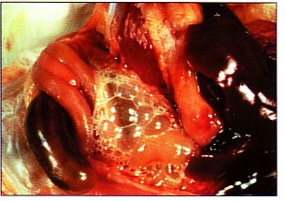 |  |  | 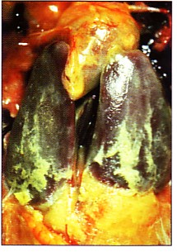
Airsacculitis |  |  | Pericarditis, peritonitis and perihepatitis are frequently observed in birds with Chronic Respiratory Disease
Fig. 12: Symptoms of Chronic respiratory disease (CRD)

Infectious coryza | Sneezing, foul smelly eye and nasal discharge, running of tears, swollen face, difficult and loud breathing, rapid spread of disease. | Catarrhal inflammation of the upper respiratory tract | Avoid overcrowding Antibiotics, vitamins and electrolyte | Vaccine
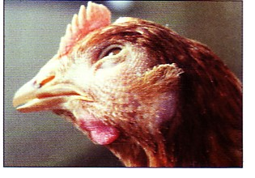
Fig. 13: Typical facial swelling due to infectious coryza

Disease | Symptoms | Post-mortem findings | Prevention | Treatment
Salmonellosis | Bacterium  Sudden death, listlessness, huddling together, droopiness, whitish pasty diarrhoea | A greenish mucoid interilis, enlarged and congested spleen, kidney and liver. Yellow, heart sack fluid containing fibrous exudate can be found on lungs and liver. | Hatchery and flock sanitation | Antibiotics, sulfas
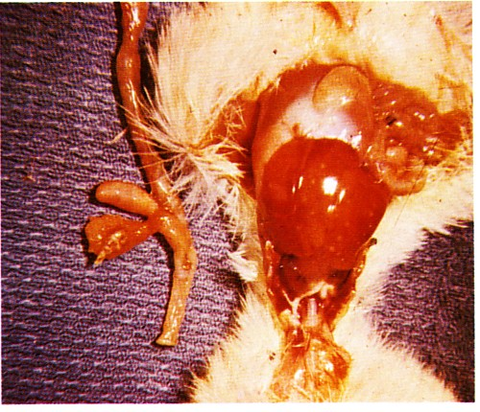
Paratyphoid
Exudate on liver and lungs is a common indication.
Ceca are filled with pale, yellowish plugs.
Some nodules appear in small intestine.
Fig. 14: Symptoms of Salmonellosis

FUNGAL DISEASES
Aflatoxicosis | Inappetence, poor growth rate and feathering, drooping head, inco-ordination.  Signs vary with the kind and degree of toxin intake. | Congestion of visceral organs. Pale and enlarged liver, spleen, pancreas and kidney. | Avoid Aflatoxin level in feed higher than 0.2 ppm.  High moisture levels in feed (>12%) encourage aflatoxins growth | High protein diet and calcium propionate 2-3 kg/tonne

PARASITIC DISEASES

Disease | Symptoms | Post-mortem findings | Prevention | Treatment
Coccidiosis | Blood stained diarrhoea and bloody droppings, listlessness, dropping of wings, unsteady gait, ruffled feathers, high mortality unless checked. | Caeca distended and filled with bloodclots, intestine inflamed and distended. Greyish white spots seen on the outer intestinal surface, while blood-tinged hemorrhagic inner intestinal surfaces are common. | Avoid overcrowding, practice strict sanitation and keep litter dry.  Use coccidiostats in feed | Amprolium

There are several species of Coccidia affecting chickens. These are described below:

SPECIES | REGION MOST AFFECTED |  | LESIONS
Eimeria acervulina | Upper half of small intestine |  | Whitish patches, thickened intestinal wall
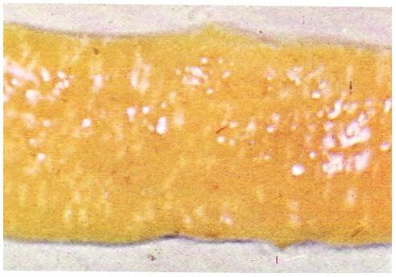 |  | 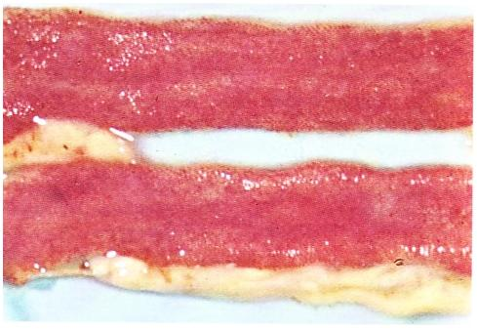
E. acervulina coccidiosis.  A light infection showing whitish patches in the upper half of the intestine. Such lesiong may be seen from the otuer side of the intestine as well as inside the organ. |  | A heavy infection showing redness of the intestinal lining. This condition may be confused with inflammation from another cause, making a laboratory diagnosis necessary.

Eimeria tenella | Ceca |  | Blood-filled ceca, hemorrhages in cecal  wall
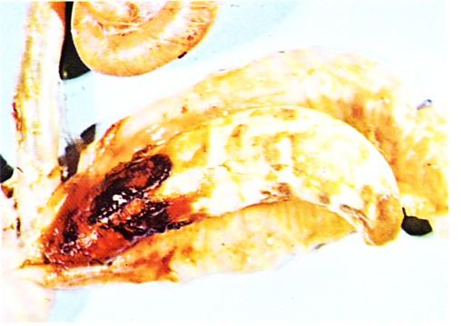 |  | 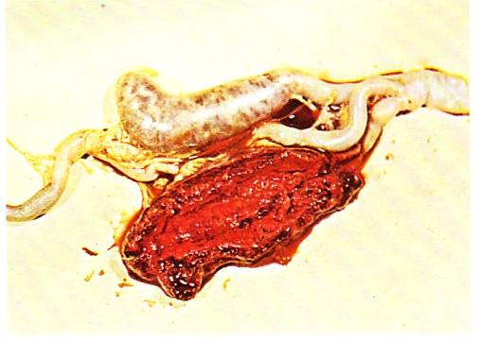
E. tenella coccidiosis  The ceca are swollen and filled with a core containing lymph, tissue cells and other debris. |  | When the ceca are opened, the bloody mass characteristic or cecal coccidiosis is shown, the result of hemorrhaging of blood vessels in the ceca.

SPECIES | REGION MOST AFFECTED |  | LESIONS
Eimeria necatrix | Middle half to entire small intestine |  | Ballooning, white spots, hemorrhages in  small intestine
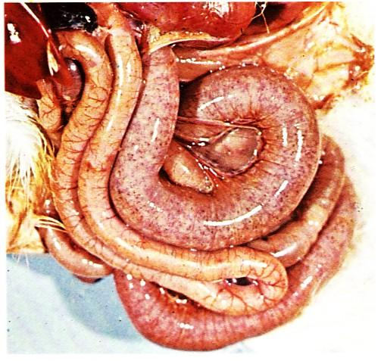 |  | 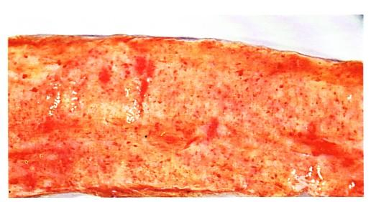
E. necatrix coccidiosis  The intestine is extremely ballooned. Hemorrhaging areas are clearly seen without opening the intestine. |  | Viewed after opening intestine and pushing aside the jelly-like mass (bloody mucus), the intestinal lining shows hemorrhagic areas.

Fig. 15: Symptoms of Coccidiosis due to various species of Coccidia

Eimeria maxima | Middle and lower portion of small  intestine | Thickened intestinal wall. Exudate or flecks  of blood on lining
Eimeria mivati | Upper half of small intestine | Similar to acervulina; however, white  patches are more oval shaped
Eimeria hagani | Upper half of small intestine | Pin-head hemorrhages. Severe catarrhal  inflammation
Eimeria brunetti | Lower half of small intestine, rec  tum, and cloaca | Catarrhal enteritis with blood-tinged exu  date
Eimeria praecox | Upper third of small intestine | Generally no significant lesions
Eimeria mitis | Upper portion of small intestine | Generally no lesions present

CONCLUSION

Broiler production has served individual farmers and Guyana extremely well in the past and by all indications it will continue to be quite lucrative. More commitment will be required and a team approach by all industry players will be required. All involved have to work together in an orchestral fashion in order to achieve success.

